Post Details |  | Last Updated: 05/06/2023
Job Title: | Fitness Consultant
Job Family & Job Level | Surrey Sports Park |  | Level 2
Responsible to: | Gym Manager
Responsible for: | n/a
Job Purpose Statement
As part of the Health, Fitness and Wellbeing Department, the post holder will ensure the delivery of high quality fitness activities and guest service, as well as the on-going development of the operation. They will help improve the health and fitness of the Centre’s guests, by leading and organising group and individual exercise programmes, as well as providing advice on nutrition and lifestyle changes.
Problem Solving, Accountability and Dimensions of the role
The post holder is expected to work with minimum daily supervision but with clear guidance from the Health & Fitness Supervisor, to deliver a high quality operation and service within the Fitness Suite. The post holder is expected to apply their technical and working knowledge of health and fitness in order to provide advice, training and assistance to staff and visitors to the facilities.
The post holder will organise and prioritise their work within an established operating environment, guided by the Health & Fitness Supervisor. They will have the latitude within their daily work routine to organise and prioritise their own work, to ensure that key deadlines and objectives are met. This will include successfully managing any conflicting demands, possessing a basic awareness of the options available and being able to make effective and appropriate decisions. The work will usually follow an established pattern, with the option to refer to well-established processes and procedures as set out by the department for guidance, when required. When faced with complex issues or problems, the post holder is expected to use their initiative and judgement to identify a suitable and timely resolution. They are however, required to recognise when problems/issues should be referred to the Health & Fitness Supervisor for guidance or resolution. In collaboration with others, the post holder is expected to develop the programmes on offer to the Fitness Suite’s guests, and as such will on occasion be required to take a creative approach to their work.
The post holder must have a confident communication style and be able to act with sensitivity and diplomacy, as they will have responsibility for providing clients with fitness, nutritional and lifestyle advice. As part of a team, the post holder is responsible for maintaining a safe environment within the Fitness Suite by complying with the necessary Health and Safety requirements and ensuring that users are aware of the guidelines in place. The post holder is expected to provide a quality and professional service, as errors in judgement or failure to carry out a particular task could place the personal safety of those operating within the Fitness Suite at risk, equipment being damaged and/or the reputation of the SSP being affected. The post does not hold any budgetary or supervisory responsibility.
Background Information/Relationships
Surrey Sports Park is at the heart of sport and physical activity in Surrey, and our mission is to deliver the best possible sport, health and wellbeing experience to our University of Surrey students and to the wider SSP community. We provide strategic added value to the University by delivering an outstanding student experience through social and competitive sport and providing an excellent environment for wellness and fitness for Surrey staff and students, and our community impact is significant both culturally and physically. The team is passionate and high performing, and the business model required us to deliver a self-sustaining, well managed and customer service focused business.
The post holder will work closely with all Sports Park staff and both internal and external guests.
This job purpose reflects the core activities of the post. As SSP and the post-holder develop, there will inevitably be some changes to the duties for which the post is responsible, and possibly to the emphasis of the post itself. SSP expects that the post-holder will recognise this and will adopt a flexible approach to work. This could include undertaking relevant training where necessary.
Should significant changes to the job purpose become necessary, the post-holder will be consulted and the changes reflected in a revised job purpose.

Person Specification This section describes the sum total of knowledge, experience & competence required by the post holder that is necessary for standard acceptable performance in carrying out this role.
Qualifications and Professional Memberships |  | Essential/  Desirable
GCSE level (numeracy and literacy) or equivalent vocational qualifications, plus basic relevant work experience  Or  A number of years experience within a similar role |  | E
Register of Exercise Professionals Level 2 Fitness Instructor qualification or equivalent |  | E
First Aid Certificate |  | E
Coaching or class instruction certificate (e.g. exercise to music/spinning) |  | D
Technical Competencies (Experience and Knowledge) This section contains the level of competency required to carry out the role (please refer to the competency framework for clarification where needed). | Essential/  Desirable | Level  1-3
Experience of working with relevant specialised equipment, software and procedures | E | 2
Experience of working independently and without close supervision | E | 2
Experience of working within a customer focused environment. | E | 2
Understanding of health and safety requirements, with particular reference to the leisure industry. | E | 2
Experience of delivering personal training and group exercise sessions to a variety of demographics | D | 2
Experience of operating a leisure management system | D | n/a
Good IT skills with the ability to learn new systems | D | n/a
Special Requirements: | Essential/  Desirable | Level  1-3
To work during unsocial hours, including early mornings, late evenings and at weekends. | E | n/a
Criminal Records Bureau Clearance | E | n/a
Core Competencies This section contains the level of competency required to carry out this role. (Please refer to the competency framework for clarification where needed). N/A (not applicable) should be placed, where the competency is not a requirement of the grade. |  | Level  1-3
Communication  Adaptability / Flexibility  Customer/Client service and support  Planning and Organising  Teamwork  Continuous Improvement  Problem Solving and Decision Making Skills  Leadership / Management  Creative and Analytical Thinking  Influencing, Persuasion and Negotiation Skills  Strategic Thinking |  | 2  2  2  1  1  2  2  1  n/a  n/a  n/a

Organisational Information

All staff are expected to:

Positively support equality of opportunity and equity of treatment to colleagues and students in accordance with the Surrey Sports Park Equal Opportunities Policy.
Help maintain a safe working environment by:
- Attending training in Health and Safety requirements as necessary, both on appointment and as changes in duties and techniques demand.
- Following local codes of safe working practices and the Surrey Sports Park Health and Safety Policy.
- Excellent environmental performance is a strategic objective for the Surrey Sports Park. All staff are encouraged to work to achieve the aims of our Environmental Policy and promote awareness to colleagues and students.
- Undertake such other duties within the scope of the post as may be requested by your Manager.
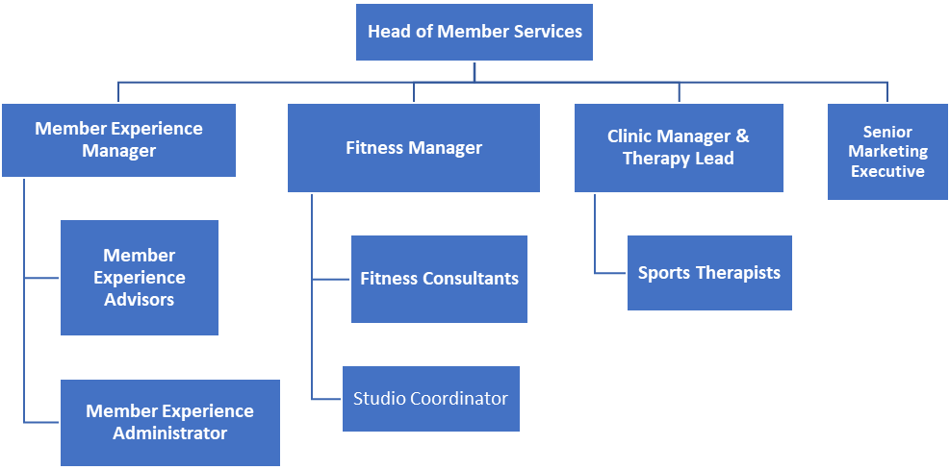
Key Responsibilities
This document is not designed to be a list of all tasks undertaken but an outline record of the main responsibilities (5 to 8 maximum) and should be read in conjunction with the accompanying Job Purpose.
- Ensure all fitness equipment is regularly monitored and maintained, taking sufficient steps to ensure the Fitness Suite is safe for all users.
- Ensure excellent customer care is provided to all users of the Health & Fitness Suite.
- Complete health and safety checks within the Fitness Suite and follow the relevant guidance for reporting any faults.
- Deliver health & fitness services and advice to customers where relevant.
- Deliver Synrgy 360 HIIT Fast Classes to customers
- Work alongside the Health & Fitness Supervisor and Health, Fitness & Wellbeing Manager, to build a successful member journey.
- Work closely with the Health, Fitness & Wellbeing team to achieve departmental targets.

